Plasticonnect

Functional Specifications
Version 1.x

Prepared by
LastSignal.com

Contents
Plasticonnect 1
Functional Specifications 1
Version 1.x 1
DOCUMENT HISTORY 3
PURPOSE 4
SCOPE 4
ASSUMPTIONS 4
OUT OF SCOPE 4
DECISIONS 4
DELIVERABLES 4
APPLICATION 4
1.1 Application Roles 4
1.1.1 Plastics Buyer 4
1.1.2 Supplier 5
1.1.3 Business Administrator 5
1.1.4 Support Users 5
1.1.5 System Administrators 5
1.2 Website Layout and Design 5
1.2.1 Login page 5
1.2.2 Registration 6
1.2.3 Home Page 6
1.2.4 RFQ Manager 8
1.2.5 Predefined Products Page 11
1.2.6 Product Manager Page 13
1.2.7 Supplier Selection Page 15
1.2.8 History Page 16
1.3 Reports 18
1.4 Page Flow 18
Glossary 18

DOCUMENT HISTORY

Version | Creation/Revision  Date | Created/Updated by | Comments
1.0 | Jan 17, 2011 | Bahram Daneshgar | Document Creation
1.1 | Jan 23, 2011 | Bahram Daneshgar | Added Product Manager Mockups
1.2 | Jan 25, 2011 | Serjik Dikaleh | Corrections
1.3 | Jan 25, 2011 | Bahram Daneshgar | Applied Serjik’s corrections and answered the review questions
1.4 | Jan 25, 2011 | Bahram Daneshgar | Added Product Manger descriptions
1.5 | Jan 26, 2011 | Bahram Daneshgar | Added Predefined Product concept and pages
1.6 | Jan 29, 2011 | Bahram Daneshgar | Project Named Plasticonnect.  Added the “Requisition Manager Tool” spec.  Added “Supplier Selection” spec
1.7 | Feb 6, 2011 | Bahram Daneshgar | Added more details to Requisition Manager
1.8 | March 4, 2011 | Bahram Daneshgar | Renamed Consumer to Buyer
1.9 | March 16, 2011 | Bahram Daneshgar | Reviewed; changed the word Requisition to RFQ
1.10 | March 24, 2011 | Bahram Daneshgar | Reviewed and corrected some parts

PURPOSE
The purpose of this document is to define a system that can be placed between plastics suppliers (manufacturing or reseller) and buyers. The Project will help buyers to get quote from different suppliers for the same product. Once a buyer submits an RFQ, the system will request a quote from the registered suppliers simultaneously and report all of them back to the buyer.

SCOPE
Anything not identified in this document and project plan is out of scope. Out of scope items can be included in the project by submitting a signed and approved change order outlining details of the change requested along with any impact to original schedule and/or costs.

ASSUMPTIONS
- Once users enter an RFQ, they are able to enter an exact quantity of the item. In addition, they are able to choose one of other two options; “Best Price” and “Min Qty”. These two options allow the suppliers to specify the quantity by the time of pricing.

OUT OF SCOPE
TO BE IDENTIFIED

DECISIONS
TO BE IDENTIFIED

DELIVERABLES
TO BE IDENTIFIED

APPLICATION

Application Roles

Plastics Buyer
Plastics Buyers are the major users of the application. They are either the end users or the resellers (distributors). They should be able to do the following even before logging in:
- To define a custom product
- To add a custom product to the RFQ (shopping cart)
They should be able to do the following once they are logged in:
- To save a custom product with a specific name (part number) for the future use; the name will be unique at the user level.
- To submit an RFQ to a specific list of Plastics Suppliers; the list is limited to the registered suppliers in the application and plastics users are able to choose to select between them.
- To place an order by changing a quote to a purchase order

Supplier
This group of users provides the plastics goods. They should be able to do the following:
- Fulfill and price the RFQs and change them to quotes and submit them to the plastics buyers
- Receive purchase orders to be fulfilled (manufacture/acquire, receive payment and ship)

Business Administrator
This group of users has the highest authority in terms of business administration. They have access to the accounts of the suppliers and buyers. They can also generate and view business reports.

Support Users
The Support Users are the users are located in a call center and answer the phone calls or reply to fax and email communication from buyers and suppliers. They are able to create/modify accounts, logs customer calls and escalate issues to the business administrators. They are also able to reset passwords.

System Administrators
This group of users is the technical users. They have the ability to assign roles, configure system parameters and get the administration reports.

Website Layout and Design

Login page
Login page includes the regular user id and password fields. The same login page is used for different application users.
Login page has a link to reset the password (forgotten password)
There will be a registration link available for the buyers. See Registration
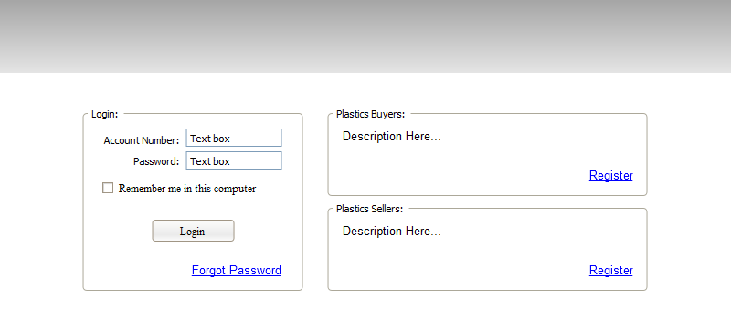

Registration
Buyers can register themselves using the Plastics Buyer Registration page. They are also able to ask support to register them over the phone.
Buyer’s Registration page mockup
Suppliers can only be registered by Business Administrators. The link on the page redirects users to the instruction of how they can register themselves as a supplier.
Supplier’s Registration instruction page mockup
Business Administrators are created by system administrators. This can be done using the existing tools to add user to the user store and assigning proper roles. No customer page is required.
Creating system administrators also can be done in the using the user management tools.

Home Page
Home page will be different based on the role of authenticated users.

Anonymous Users’ Home Page
Note: consider to move the concept of Anonymous Home Page – which does not make a sense – to the welcome page or other public page. Anyways, they need to add an item to the RFQ without logging in.
Users are able to perform certain activities before logging in. Most of these activities relate to finding information. However, there is an important activity that they should be able to perform, which is the ability to create a quote. Additionally they should be able to make custom products and add them to the quote.
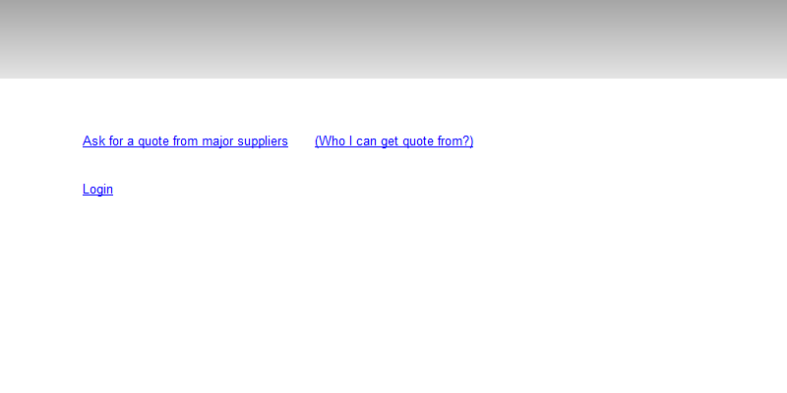

Buyers Home Page
Buyers see system related messages in the top section of the page contents
The main area of the buyer page is the Bulletin section. All business related notification appears on this section and user is able to click on any of them to perform the corresponding actions.
List the different type of Bulletin Actions
Comparison Table of the suppliers

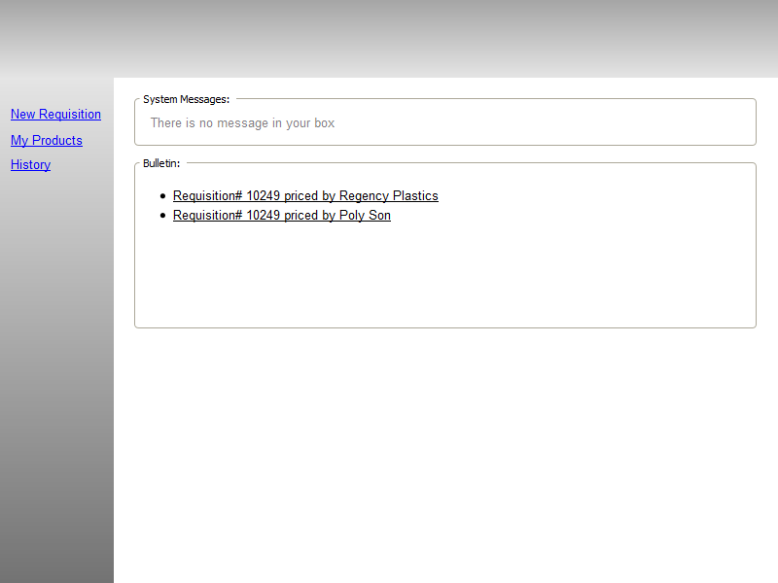

Suppliers Home Page
Suppliers Home Page has a bulletin board similar to the Buyers Home Page with the different type of Bulletin actions. In addition, suppliers see statistical information of the buyers.
List the different type of Bulletin Actions

      - Business Administrators Home Page
To be defined

Support Users Home Page
To be defined

System Administrators Home Page
To be defined

RFQ Manager
RFQ Manager is a tool to create and modify an RFQ. RFQ Manager acts different in the different circumstances. Generally, the focus of this tool is to enable user to:
- Create/modify the delivery options
- Create/modify the items
- Assign/modify the payment term

In addition, support users and business users are able to change the active customer in their session where as the other users aren’t.
Area | User Roles | Actions
Creation | Anonymous User | Anonymous users should have the ability to create custom products and create an RFQ. However, the system will ask them to login/register once they want to submit the RFQ.
Creation | Buyer | They are able to create an RFQ and submit it for pricing.
Creation | Suppliers | They cannot create an RFQ
Creation | Support Users | They are able create an RFQ and submit it on behalf of the buyers.
Creation | Business Users | They are able create an RFQ and submit it on behalf of the buyers.
Creation | System Administrators | They cannot create an RFQ
Bill to | Anonymous User | Stays empty
Bill to | Buyer | Displays the registered account name, address, phone and fax
Bill to | Suppliers | Displays the registered account name and address, phone and fax; Suppliers also have the ability to manage the account in the CRM section. This will be done using the Manage Customer link in the submenu.
Bill to | Support Users | Displays the registered account name, address, phone and fax
Bill to | Business Users | Displays the registered account name and address, phone and fax; Business users also have the ability to manage the account in the CRM section. This will be done using the Mange Customer link in the submenu. Managing accounts by business users will be different than the suppliers.
Bill to | System Administrators | Displays the registered account name, address, phone and fax
Ship to | Anonymous User | Stays empty
Ship to | Buyer | Displays a textbox for the user to enter the postal/zip code of the destination; Also displays a combo box showing a list of available predefined ship-to locations. Selecting any item in the list will replace the postal/zip code with the corresponding selected item code.
Ship to | Suppliers | They will see a static postal/zip code of whatever the buyer entered. Full ship-to address will be revealed only if PO is in placed and the delivery type is not Pickup
Ship to | Support Users | They are able to change the ship-to address / postal code or zip code on behalf of the buyers. They will be instructed not to change this on behalf of the suppliers.
Ship to | Business Users | They are able to change the ship-to address / postal code or zip code on behalf of the buyers.
Ship to | System Administrators | They are not able to change this area
Payment Terms | Anonymous User | invisible
Payment Terms | Buyer | A textbox enables users to enter their desire terms. However, supplier can overrule it later.
Payment Terms | Suppliers | The user will see the requested terms by the buyer. However, there is a textbox asking to provide the new value. System will keep both requested value and overruled value.
Payment Terms | Support Users | They are able to change the term on behalf of the suppliers while the buyer has not view the quote. They are also trained not to change the terms on behalf of the buyers.
Payment Terms | Business Users | They are able to change the terms on behalf of suppliers.
Payment Terms | System Administrators | Read only view of both requested and provided value.
Items | Anonymous User | Displays three columns: Qty, Product and Unit Price.  Qty will be a textbox enable them to enter the number. There will be also two links attached to the qty textbox enable user to ask for the “Minimum Qty” and “Best Price Qty”.  UOM is a dropdown containing the valid unit of measurement that can be applied on the product. User is able to change it based on request.
Items | Buyer | Same as anonymous user
Items | Suppliers | There are four columns appearing in each row. Quantity is a static number that the buyer has requested. However, if buyer has asked for the “Minimum Qty” or “Best Price Qty”, there will be a textbox available to the user to enter the appropriate quantity in there.  UOM is static for the user. However, if buyer has selected “Min Qty” or “Best Price Qty”, the dropdown will be available for the user to change the it.
Items | Support Users | Users are able to do anything on behalf of the buyer and suppliers. The same limitation will be applied to them.
Items | Business Users | They are able to do all changes to the items with the same limitation that support users have.
Items | System Administrators | No changes allowed.
The following mockup, illustrates the RFQ Manger page for the anonymous user:
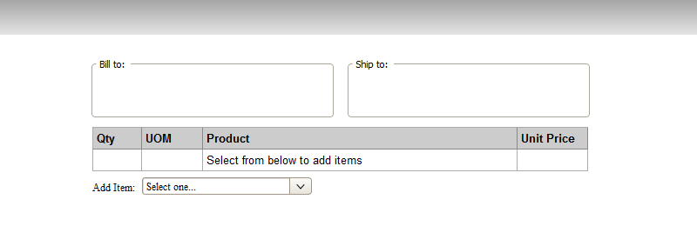

The system will redirect users to the product manager module upon selecting the product from the Add Item combo box. The following mockup shows the RFQ Manager page after one item added to it:
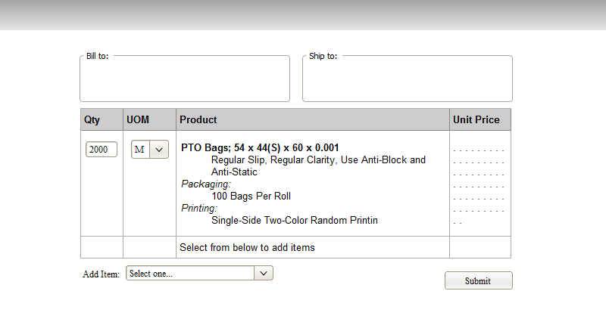

Predefined Products Page
Buyers should be able to define a product and save it for the future single or multiple uses. They save products by their part number. Part number is a unique string within a buyer scope. Different buyers can have the same part number assign to any product definition that they make. Adding a new product to the list is done by redirecting to the product manager page.
Part number validation: Part# can be different from customer to customer. However, we should allow a limited size of string with a limited variety of the characters. “([a-z]|[A-Z]|[0-9]|\-|\+){1-}” is a logical way of having a part#.
Predefined Product Page displays a list of products that have already been added.
Buyer should be able to change any of the items by being redirected to the product manger page.
Buyer should be able to delete a predefine product. This action does not affect any existing usage of part number on the previously submitted RFQs, quotes or orders.
Buyer should be able to rename a part number as long as the new name is not a duplicate name. This action should be done on this same page. Again, the action doesn’t have any impact on the previously submitted RFQs, quotes or orders.
Buyer should be able to add any of the existing items in the list to the Active RFQ. This action causes the user to be redirected to the RFQ Manager Page.
Buyer should be able to filter the list by typing the part number in the provided search box. As soon as the user starts typing, the list should be filtered by the search pattern through the part numbers only.
Support Users and Business Users are able to enter and edit predefined products on behalf of the buyers.
When the list is empty the page looks like the following:
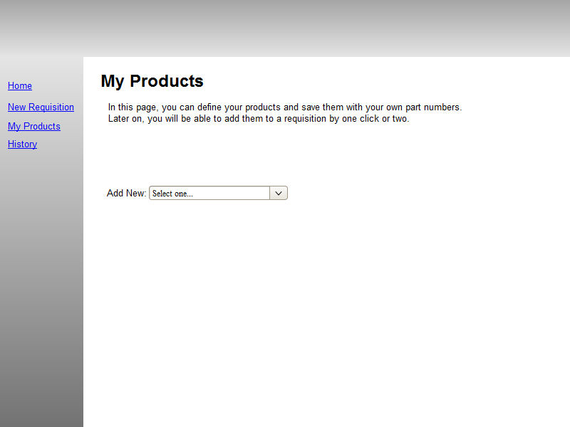
Here is a mockup of the page when it has some items in it:
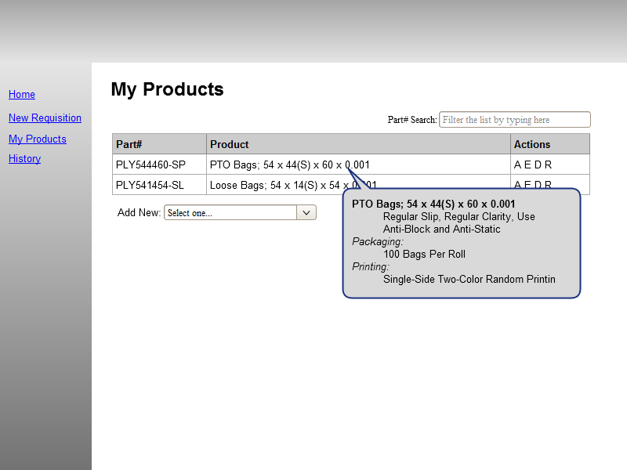

Product Manager Page
Product Manager is the tool to create or edit custom products.
This module should be available for anonymous users as well as the authenticated users. The output of the module can be added/overwritten to an RFQ or saved/overwritten as a predefined product
See the Predefined Product Page for more detail about the Predefined Products.
Once user types the values in, the corresponding description should be updated on the page.

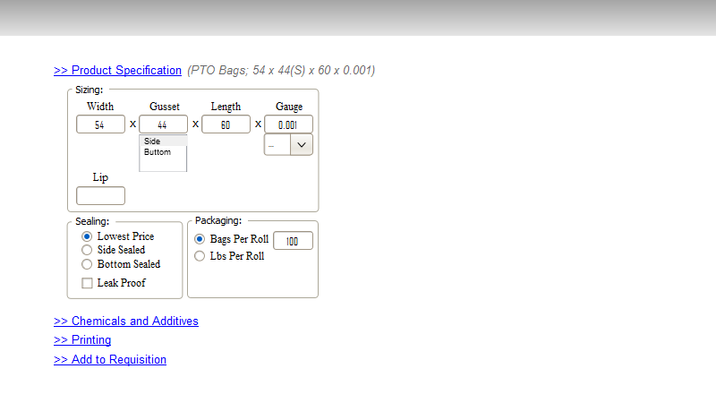
Different sections of the module are acting as accordion. Selecting one section header causes the others to be collapse.
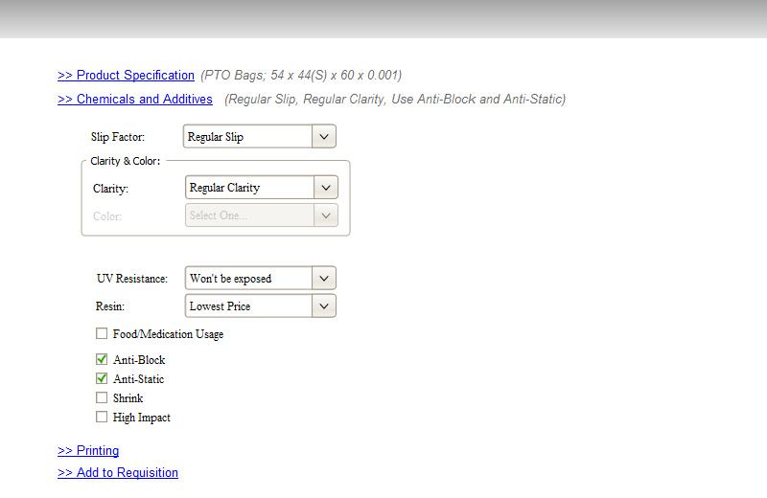
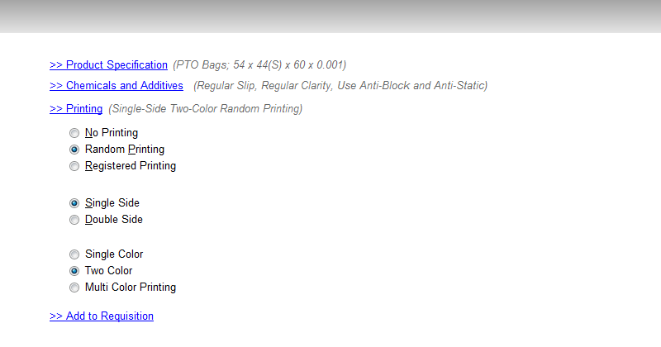
In the last section, the description of the item is displayed. If there any validation error exists, it will be shown up in red guiding user to fix it.
In addition, there should be an area for the user to assign a part number to the product. This will cause the product to be saved to the Predefined Products List. If the part number is entered, an additional text box should appear for the user to enter any optional notes for the product.
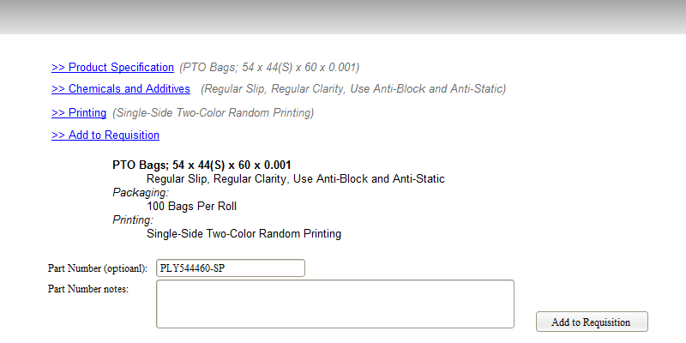

Supplier Selection Page
The page appears upon submitting an RFQ asking for a quote. Buyers are able to choose to whom they want to send the RFQ. The system will show a list of all suppliers who are able to provide the items based on the item description and are able to ship to the destination location.
In addition, the system gives users the option of adding a new supplier. If a buyer fill the new supplier information and submit it, the system will notify all Business Users to take the proper action in order to add the supplier to the list of suppliers.
The system will redirect user to the history page.

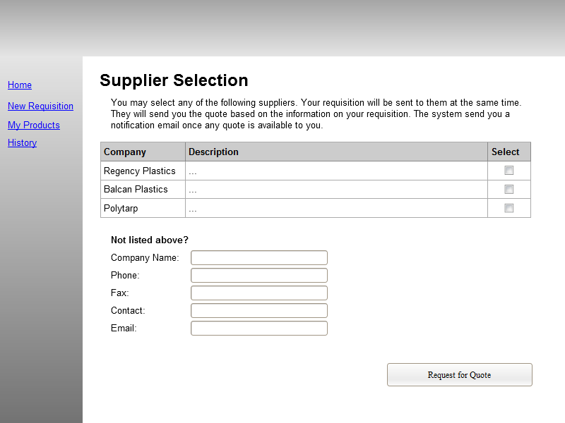

History Page
The history page displays the buyer activities in a list.
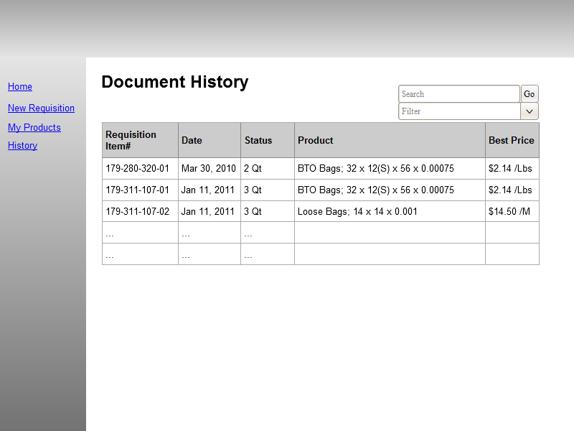

Reports

Page Flow
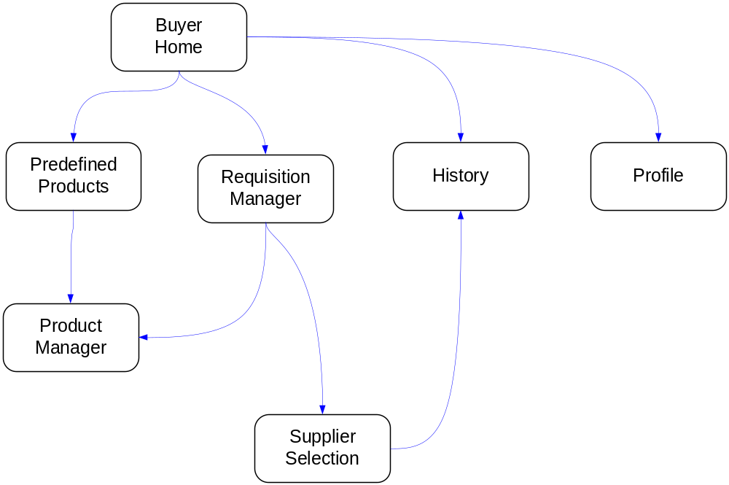

Glossary
RFQ
A request for a quote that is submitted by the Buyer
Quote
Order
In this document Order are the same as Purchase Orders
PO
See Purchase Order
Purchase Order
Approved quote by the plastics users. This is the contract document between the end user and the supplier in regards to the purchase.
System Admin User
Business Admin User
Supplier User
Suppliers can be plastic manufacturers or plastics distributors.
Buyer
The buyers of the plastics who are the most popular users in the application;
They can be plastics end user or plastics distributors.

